Dandelion and Snail Forest Preschool
Sunshine group held from 8:10-11:40
River group held from 12:20-2:50

Our Forest Preschool follows the philosophy that everything children learn inside, they can learn outside with fresh air, nature as its backdrop, and the space to move about as three and four year olds are meant to.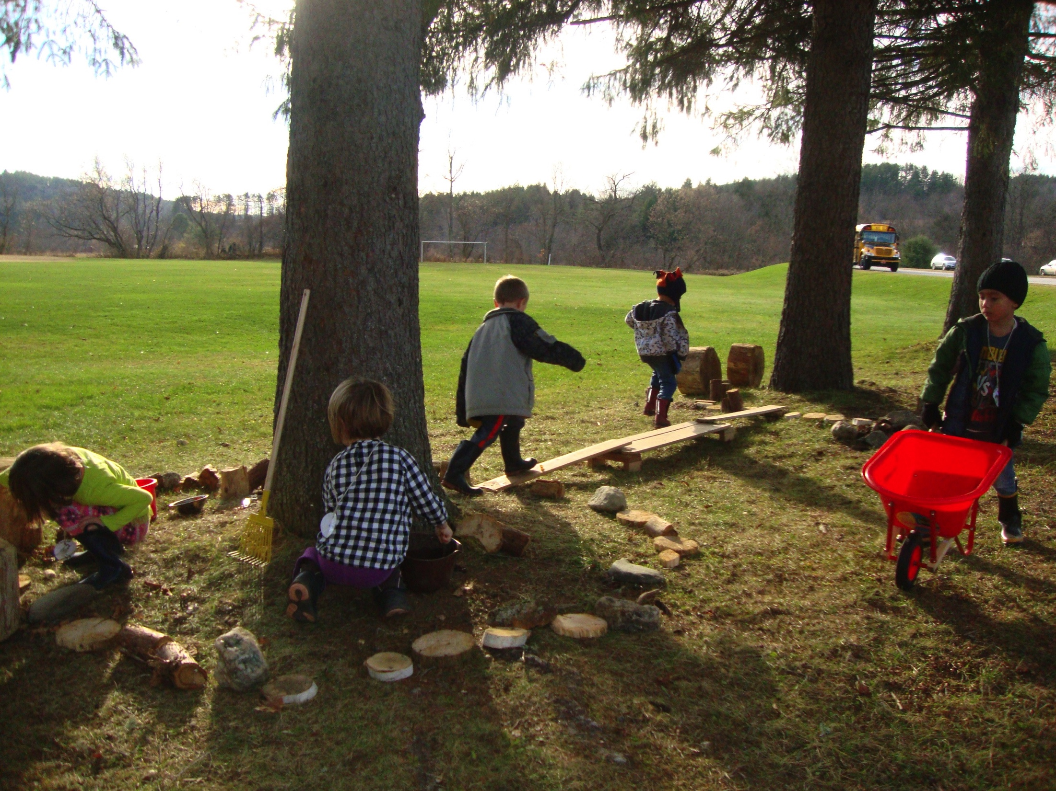
There are five main components that are the pillars to my program, the first is that we respect, honor and understand the whole child. We work carefully to create a community of learners who feel understood, respected and loved. For young children this means providing them with space and open-ended materials that encourage exploration. The right amount of freedom and opportunities for appropriate risk taking let children know that you understand them and their needs, that you trust them and respect them. The outdoors provides many of these crucial pieces naturally.

Helping children understand themselves
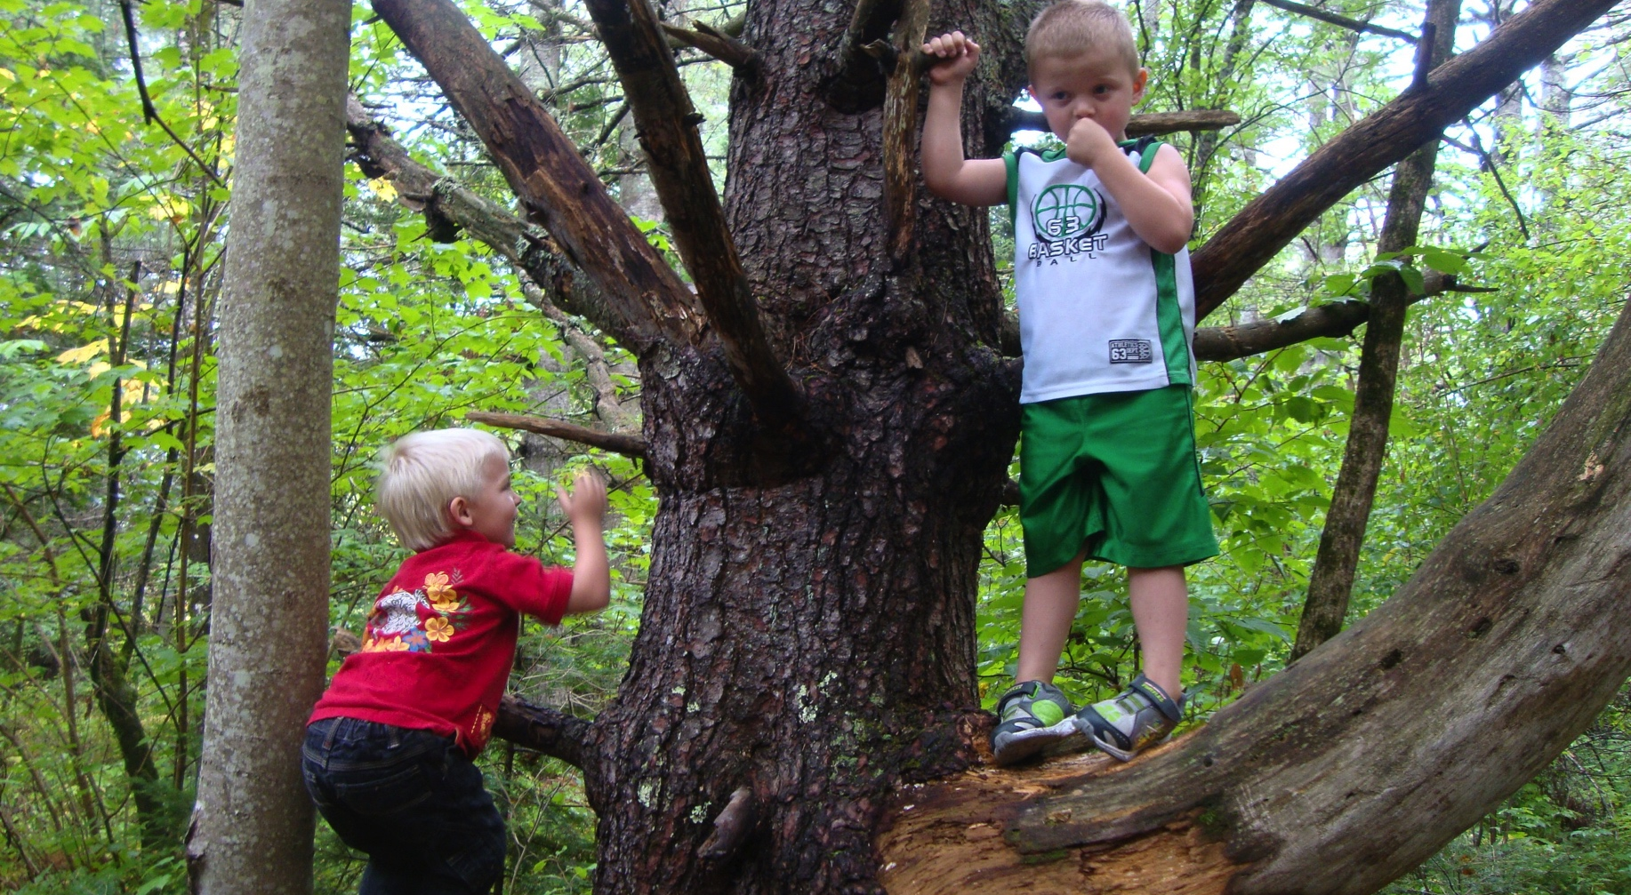
To understand yourself is to have the freedom to experience and to reflect on your reaction to an experience. With the careful guidance of teachers, children in our forest program are given the freedom to explore not only nature, but themselves in nature during all seasons. This means the children have first hand experience noticing the seasons and the joys that come with each one. We begin the school year with a lot of water play in our mud kitchen where we explore such concepts as empty, full, sink, float, and endless scientific concepts associated with water. As the seasons begin to change we observe how the air changes, the smell of the earth shifts and the leaves begin to fall. Together we make piles of leaves to jump into, create forts and bring leaves back into the classroom for weaving, rubbing and identifying.

Understanding others
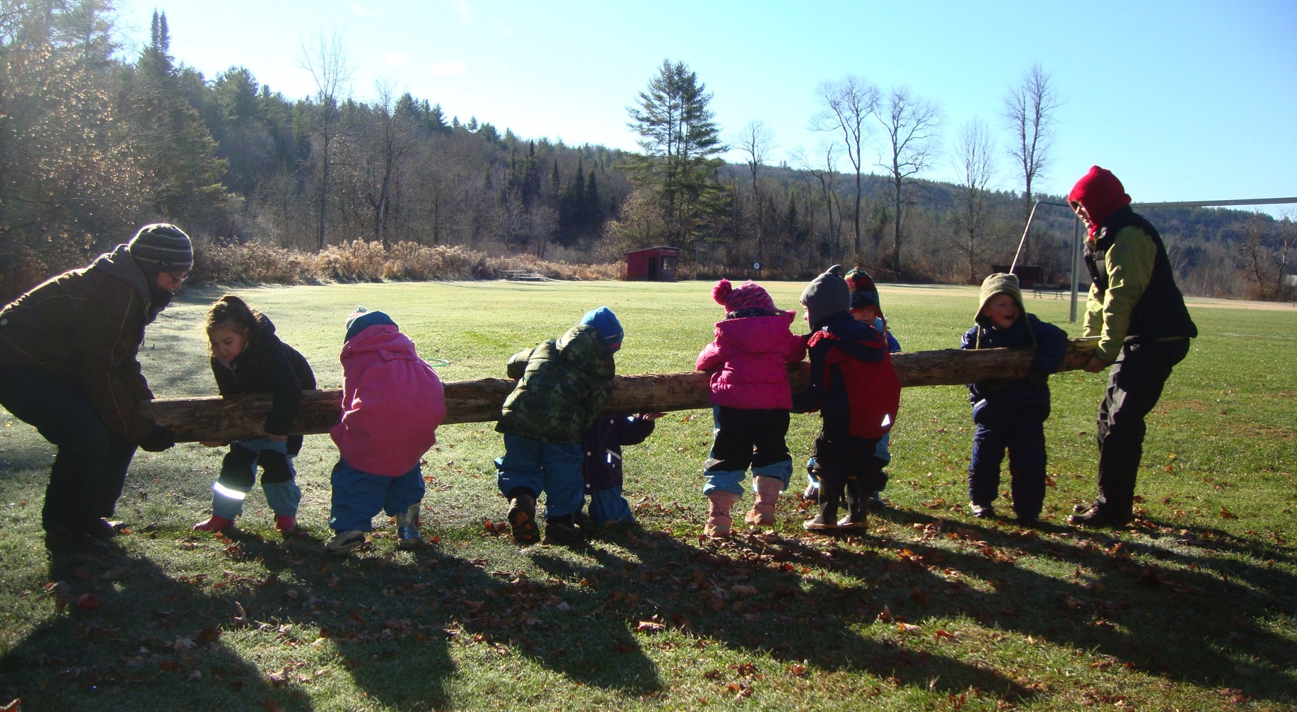
When working with others to solve a common goal you have to listen to them, both their words and their body language. You have to think of yourself as one in a group, not just one person standing alone. When you succeed and accomplish what you set out to do, you can share in the joy of that moment with those who helped you get there. Outdoors there are endless opportunities to help each other reach your goals with the space and freedom to move big.

Helping children to grow a wonder about the world around them
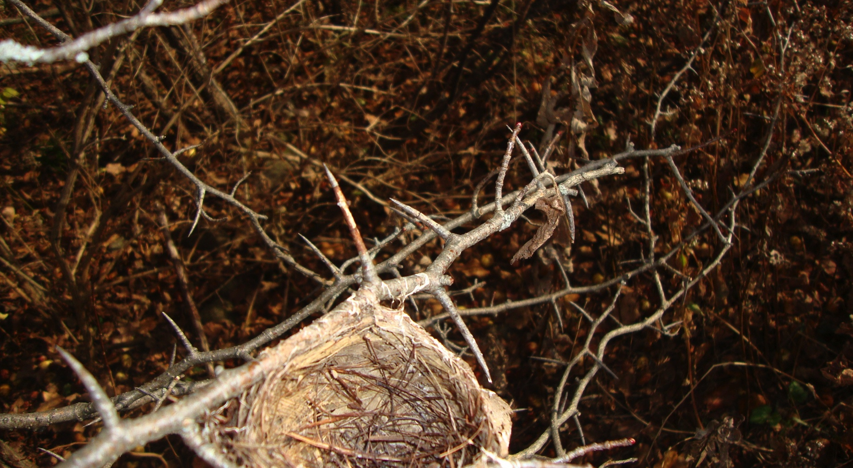Teachers and children never know what they will find in nature, which is part of the allure and excitement of being outdoors. The environment is forever changing, causing new questions to bubble to the surface. You have to be observant, quiet and curious. These are all skills that would help any adult be successful in the world. Finding a nest leads to such questions as, who lives there, where did they go, why are there thorns on this branch and how did they make this nest?

Teaching children to think creatively and take risks
Open-ended materials and space encourage children to explore with materials and use them in various ways. I have found that materials provided by nature encourage creativity, imagination and critical thinking more than any store bought item you may find in a typical preschool.

“As a child, one has that magical capacity to move among the many eras of this earth; to see the world as an animal does; to experience the sky from the perspective of a flower or a bee; to feel the earth quiver and breathe beneath us; to know a hundred different smells of mud and listen unselfconsciously to the soughing of the trees ”~Valerie Andrews

